STUDIO SALE 2018
MELANIE MACDONALD

FISHING:

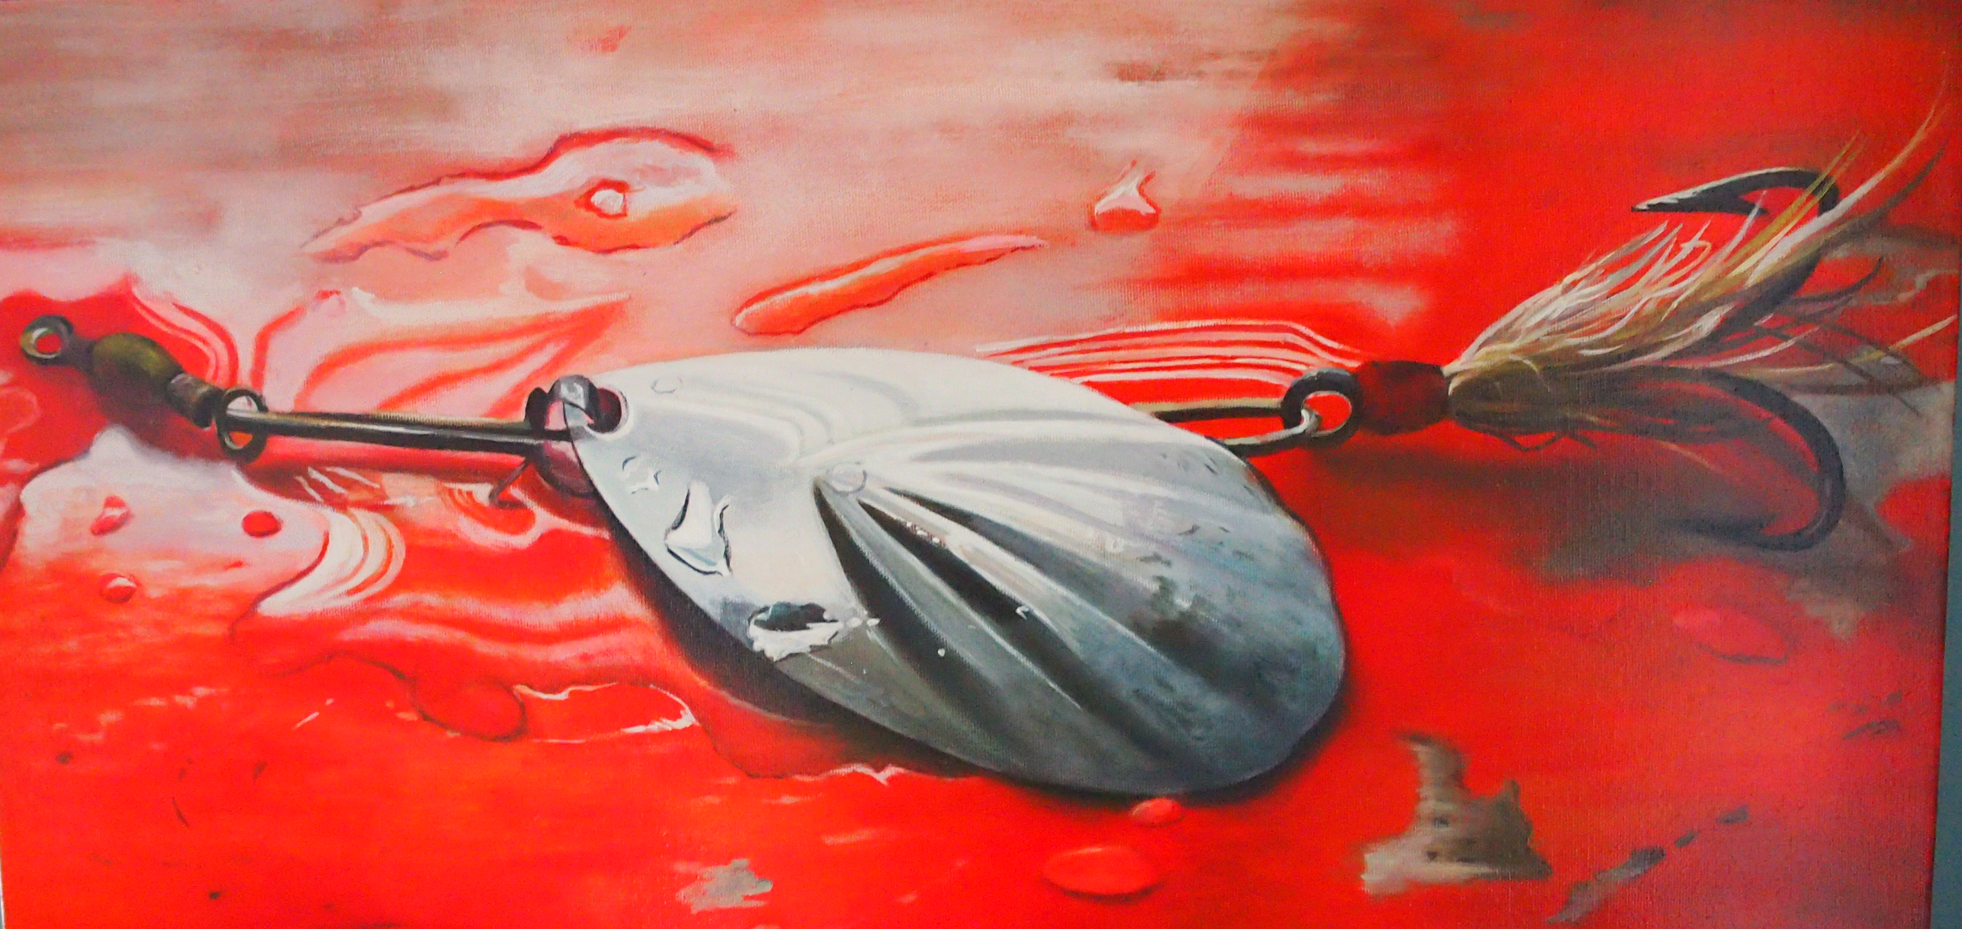
Spoon. 12x24” $600

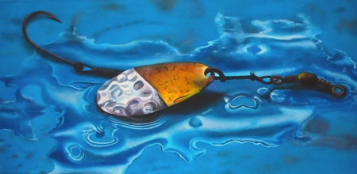
Hammered Metal Spoon. 12x24” $600

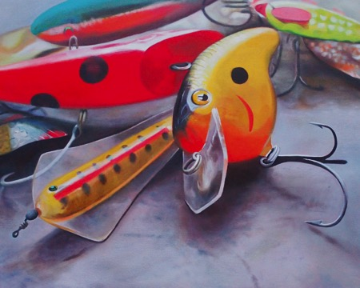
Wayne’s Australian Lure and Rapala Crawdad.
30x24 $750

CERAMICS:

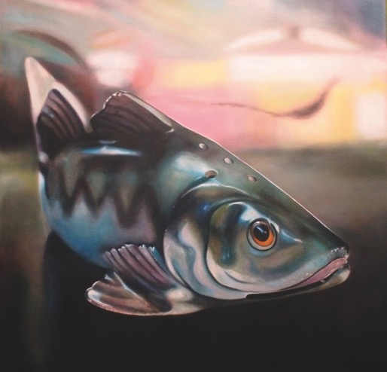
Yellow Perch. 48x48” $2800

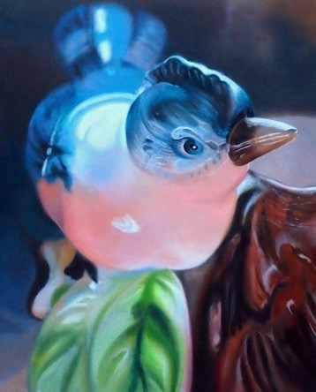
Bird Planter 30x24” $750

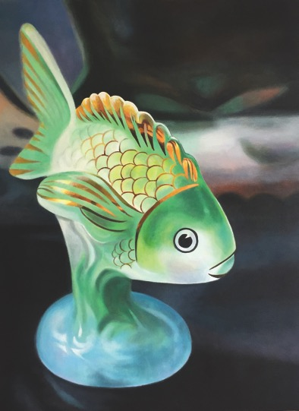
Green Fish 40x30” $1200

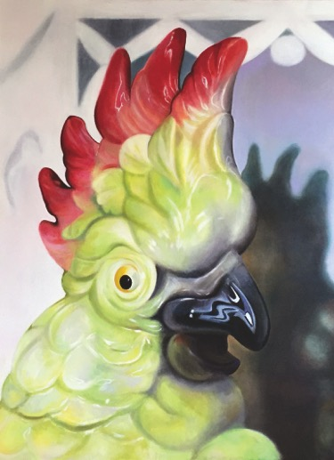
Cockatoo 40x30” $1200

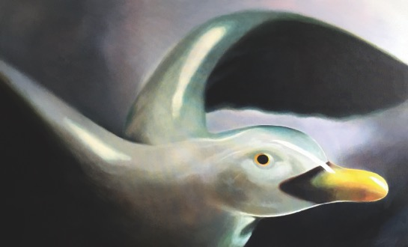
Gull 30x48” $1200

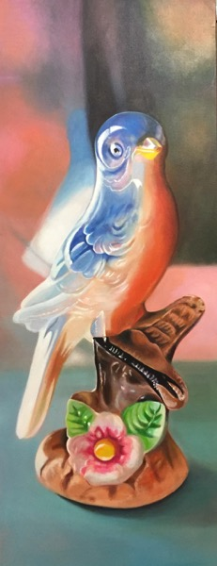
Blue Bird. 40x15” $700

LICHENS:

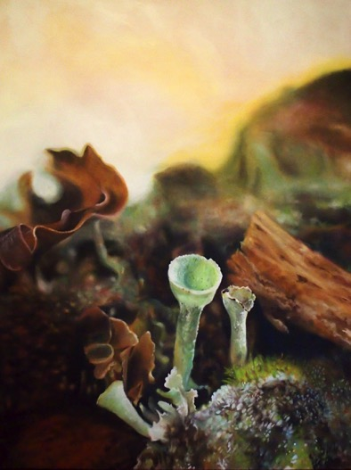
Forest Floor, Alice, ON 60x48” $2800

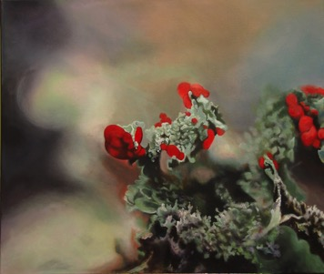
British Soldier Lichen (framed-white)
30x24” $800

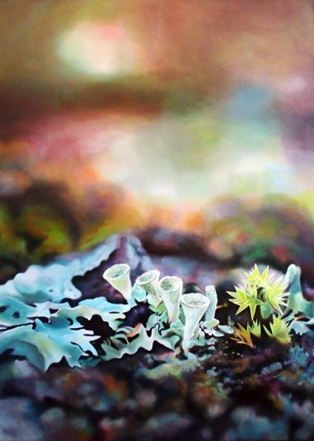
Pixie Cup Lichen 48x36” (framed) $1800

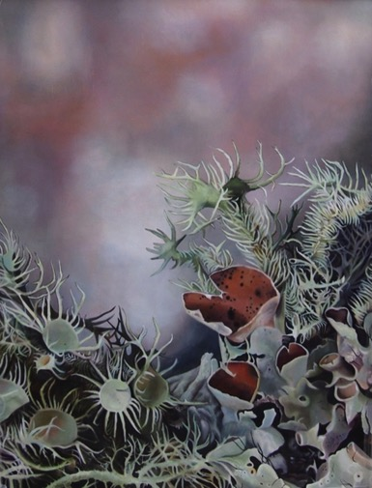
Lichen Apalachicola FLA. 48x36” (framed) 48x36” $1800

SCRAPBOOK/COLLAGE PAINTINGS:

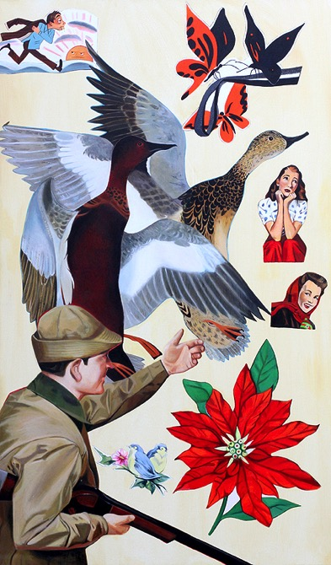
Bird Hunter 60x36” $950

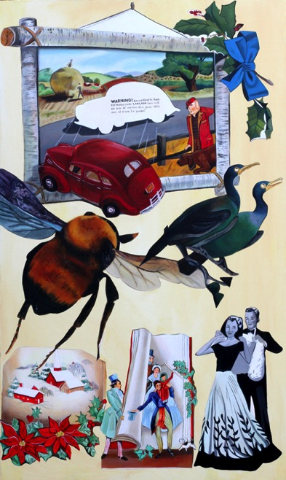
Freeze Frame 60x36” $950

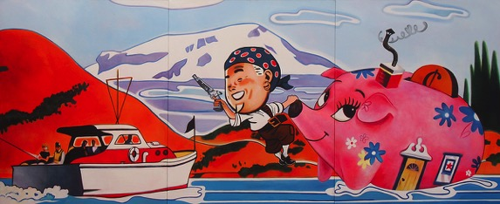
If Pigs Could Float 60x144” $3000

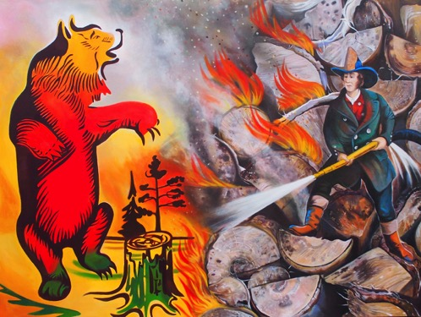
The Great Burning 2031-2033 (for Will McClelland)
36x48” $800

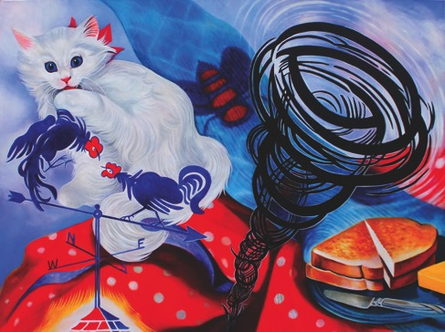
You Can’t Run From The Funnel of Love
36x48” $800

